PLEASE PRINT CLEARLY
THE 2020 JAPAN EXCHANGE AND TEACHING (JET) PROGRAMME
CERTIFICATE OF HEALTH
To be completed and signed by examining physician. Physician must not be a relative of applicant.
To the Examining Physician (PLEASE READ THOROUGHLY)
You are asked to evaluate the physical and mental health of the applicant for the JET Programme. Participants of the JET Programme will be assigned for one year to schools or to local government offices in Japan. It is extremely important that all participants be able to adjust to dramatic changes in climate, diet, and living conditions. Living and working overseas can also create emotional and physical stresses in response to the demands of living in a new and different environment. In some cases, mild disorders can become serious due to the stress of life and work in foreign surroundings. It is essential that your reply be based on a current and thorough physical examination and knowledge of the applicant’s medical history.
NOTE: PLEASE FILL IN ALL SECTIONS. ANY MISSING INFORMATION INCLUDING QUESTION 7 MAY HINDER OR PREVENT A CANDIDATE FROM PARTICIPATING.

- Applicant’s Name:
(Last Name) (First Name) (Middle Name)
Date of Birth: M /D /Y Age: Sex: □ Male / □ Female

- Physical Examination Height: Weight:

Blood Pressure: mm/Hg ~ mm/Hg Pulse Rate: /min
□ regular / □ irregular
Eyesight: (R) (L) (without glasses)
(R) (L) (with glasses or contact lenses)
Colour Blindness: □ normal / □ impaired Hearing: □ normal / □ impaired (If impaired, ok to drive: □)

- Urinalysis: glucose ( ) protein ( ) occult blood ( ) (neg, +2, -, etc.)

4. Past history: Please indicate with an X if applicant has ever had any of the following, and fill in the specific name of the disorder and the date of recovery:
□ Tuberculosis ( / / ) □ Malaria ( / / )
□ Other Communicable Disease ( / / )
□ Epilepsy ( / / ) □ Renal Disease ( / / )
□ Cardiac Diseases ( / / ) □ Diabetes ( / / )
□ Drug Allergy ( / / ) □ Functional Disorder in Extremities ( / / )
□ Mental Disorder(s) (including but not limited to ADD, ADHD, depression, anxiety, eating disorders, obsessive compulsive disorders)
( / / )
□ Other (please specify) ( / / ) ( / / )

5. X-ray Examination: Please describe the result of the applicants physical and chest X-ray examination (X-ray(s) taken more than 3 months prior to the certification is NOT valid). Results of tuberculosis test must be provided regardless of vaccination history if the X-ray information is not completed below. Please note: As a rule, all applicants who test positive in a PPD test, regardless of chest X-ray results, MUST SUBMIT A BLOOD TEST, OR TAKE DRUGS TO SUPPRESS TUBERCULOSIS BEFORE COMING TO JAPAN.
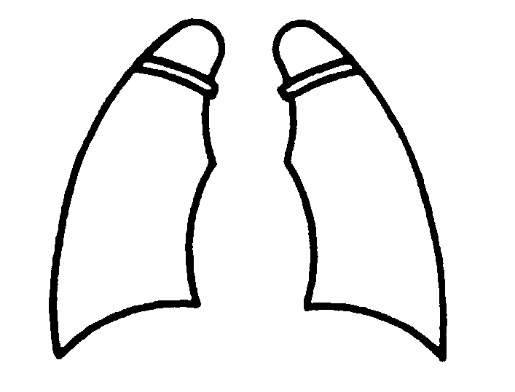
Lung: □ normal / □ impaired
Date of X-ray:
Cardiomegaly: □ normal / □ impaired
Describe the condition of applicant’s lung:

6. Please add any other information, whether or not requested on this form, which might be pertinent to the applicant’s ability to teach or take part in the activities of the JET Programme (eg. pregnancy, physical disability, drug addiction, etc.).

7. In view of the applicant’s history and the above findings, is it your observation his/her health status is adequate to go abroad to participate on the JET Programme? □ YES □ NO
<MUST BE SIGNED BY A PHYSICIAN WITH A D.O. or M.D>
Date: Physician’s Signature:
Physician’s Name in Print:
Office/Institution:
Address:
TEL: FAX: E-mail:

